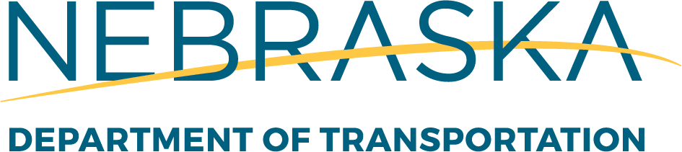

Federal Funded Research Program Development

Through the Year
Solicitation for Statements of Need (SON)
- Statement of Need Form on website

Mid-September
Statements of Need Due
- E-mail SON form to NDOT Research Program Manager
- No late submissions will be accepted

Early October
Nebraska Transportation Research Council (NTRC) Meetings
- Attended by NTRC Members – NDOT, Industry, Academia, FHWA, Counties and Cities
- 4 Focus Groups/4 Review Sessions
  - Roadway, Hydraulics and Environmental (RHE)
  - Structures and Geotechnical (SG)
  - Materials, Pavement, Maintenance and Construction (MPMC)
  - Traffic, Safety, Planning and Technology (TSPT)
- NTRC members will vote and prioritize which statements of need will move onto the proposal writing phase
- Research Program Manager will send E-mail out to researchers with results

Late October and Early November
Proposal Frame Review
Principal investigator will meet with TAC members to review Objective, Expected Benefits, Tasks, and Implementation. PI will work with their TAC members during the proposal development. The TAC members will have the opportunity to provide guidance during the proposal development before it can be considered for funding by the NDOT Research Advisory Committee (RAC).
December
Research Proposals Due
- Proposals must be submitted by Office Sponsored Programs before being submitted to the NDOT Research Section
- Research Proposal template & budget template on website

January
Research Advisory Committee (RAC) Meeting
- NDOT Division Heads and District Engineers
- RAC vote on which proposals will be established/funded for the next Fiscal Year Nebraska Research Work Program

February
Establish Next Fiscal Year Research Projects
- Research Program Manager will send E-mail out to researchers with results
- Funding begins July 1st Research Projects (23-Months

